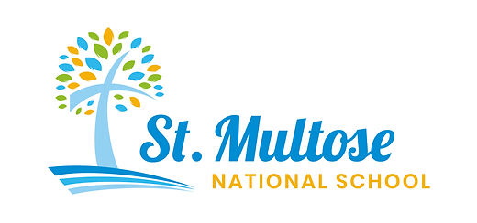

Celebrating 40 years
in our current location
1 9 8 6 – 2 0 2 6

Newsletter 7th January 2026
Dear Parents,
This year, we are celebrating 40 years of St Multose School being in its current location. Throughout the year there will be several events to celebrate this special time in our school’s history. You will be hearing about these in due course.
Thank you
On behalf of all the staff, thank you to the Parents’ Association and all the parents, for the very kind Christmas gifts, especially the generous gift voucher for staff to have a meal out. It is very much appreciated by us all.
Hot School Meals
BiaÓg visited the school yesterday in preparation for the delivery of Hot School Meals beginning Monday 12th January. Please choose your meals on the portal. If you don’t remember to choose, your child will get the default meal for that day.
Please remember to pack some fruit and/or a yoghurt for small break and a spoon/fork to eat the hot meal.
For your information, if there is a school trip during the year, for now, we will notify BiaÓg and there will be NO lunch provided by them. In this case, parents will pack a lunch for their child on those days.
Swimming
Swimming commenced for the Junior classroom yesterday, 6th January and will continue for 5 more weeks. Please remember swimsuit, goggles, towel and a swimming hat.
Modern Foreign Languages – French
Bonjour! Nous commencerons les cours de francais ce trimester. We are delighted that Ms Hadden is now teaching French in our school. Every Monday for an hour for the next ten weeks, she will be working in the senior classroom. She will also be teaching French in the middle classroom.

Parents’ Association
- PA Meeting: The Committee with meet on Thursday 22nd January in school, 7.30pm. Zoom available, if necessary.
- Re-turn Deposit Return Scheme
The orange bin in the playground is for collecting plastic bottles and drinks cans. Please donate your bottles and drinks cans to the school and help us raise funds. Give your child the job to deposit them first thing in the morning as we assemble for school. We will shortly make a spot for it beside the gate, so it will be accessible by reaching over the wall.


- Golf Classic – We intend to host a Golf Classic later on in the year as a major fundraiser for the school.
*We’ll keep you posted as we know more!

- Garda Vetting is offered for parents who wish to help at various school sporting events and other activities throughout the year. Please contact Katie in the office if you have not yet been vetted by the school and wish to do so.

- Easter School Clean-up We will have a day over the Easter holidays when we will invite families to come to the school to help clean up the grounds; we hope to do some painting, gardening and a general tidy-up. We will keep you posted with a date for this.

- We plan to have a Garden Party to celebrate 40 years of St Multose NS in its current location. This is going to be utilised as both a PR and fundraising opportunity for the school as well as a lovely social occasion for our school community.
*More information to follow.

- One of our parents, Tori, has kindly offered to be the PR representative for the school and keep our social media up to date. Please, like and share everything she puts up! We are really going to try to promote our school even more this year.

Blue Star Programme
The Blue Star Programme is an education initiative for primary school pupils across Ireland. The idea of the Programme is simple: to foster better understanding and knowledge of the European Union and how it affects the lives of Irish citizens among primary pupils through classroom activities. There are four key elements of the Blue Star Programme. These are: history, geography, culture and creativity, and Institutions of the EU. The Blue Star Programme aims to introduce participants (pupils, teachers, parents and the wider community) to the EU, what it means and how it works.
This year, 4th, 5th and 6th Class will be learning about the fourth element of the Blue Star Programme which is the Institutional Element of the Programme with Ms Roberts as she represented St Multose N.S. in Brussels last July 2025 on the Irish primary and secondary teachers’ three day ‘Study Visit to the EU Institutions’, hosted by the European Commission in Ireland. Ms Roberts is very excited to teach the students of St Multose N.S. about her visit to the European Commission and European Parliament, having roundtable discussions with the Irish MEPs as well as the EU Commissioner for Democracy, Justice, the Rule of Law and Consumer Protection Mr Michael McGrath!
This term with Ms Roberts, students in the senior classes will learn how the EU works, how the different institutions cooperate with each other and the impact of the EU on their lives. They’ll also be exploring how the EU was founded and why Ireland joined the EU in 1973. Students will get the opportunity to hold their own mock election. Who knows! We may have some future MEPs in the senior classes of St Multose N.S. in our midst!
Drama Club Term Dates
Term 1 will run for 6 weeks starting Monday the 9th of February to the 23rd of March 2026. No class on Monday the 16th of March due to the school closure for the extra day off for St Patrick’s Day. The club runs on Mondays from 2:30pm-3:30pm in the Síológa classroom.
Term 2 will run for 6 weeks from the 13th of April to the 25th of May 2026. No class on the 4th of May due to the May Bank Holiday weekend.
Picker Pals
Ms Curtin’s class will be getting involved with a lovely initiative where they are encouraged to go on a walk with their family, pick up litter using our special equipment, take a photo and tell us about their litter picking adventure.

EDS Grant aid for Polytunnel
A huge thank you to Ms Nestor for all the work she put in applying for the EDS Grant. We were awarded the full amount, €2500. With this money we will further develop and maintain the existing school polytunnel to grow fruit, vegetables, and herbs as a hands-on learning project with the support of two horticulturalists from Kinsale, Donal Chambers and Grace Clark. This initiative will provide pupils with the opportunity to engage directly in sustainable food production while exploring broader themes of climate action, biodiversity, and responsible consumption.


Safe Route to School Programme Grant
A massive thank you to Ms Hadden for driving this application last year. Amazingly, we are one of only three schools in Cork County, and one of 105 schools nationwide who will be given very significant funding to bring new safety measures near the school to make walking, wheeling, and cycling easier for school children. These improvements include school zone features such as pencil shaped bollards, colourful road markings, upgraded footpaths, and enhanced pedestrian crossings, designed to slow traffic and make it safer for students. This is a game changer for our school and something we have been lobbying for a long time. Ms Hadden wants to acknowledge the help she received from local Councillor Marie O’Sullivan who brought it up at County Council meetings. Fantastic news.
Creative Clusters
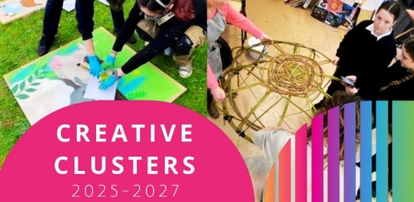
As part of our Creative Clusters Project Bernadette Tuite will be doing Ceramics with the whole school. The children and staff will each prepare two clay tiles which will be fired in the kiln. These will be displayed in the school to form part of our celebration.
Upcoming dates for your diaries:
Monday 2nd February St Brigid’s Day Bank Holiday
Wednesday 4th February – Staff Curriculum Training Day WCEC – No school or afterschool.
Thursday and Friday 19th-20th February - Midterm
Tuesdays 6th, 13th, 20th, 27th Jan, 3rd, 10th February – Swimming for Junior Room
Wednesday 6th May – Staff Curriculum Training Day WCEC – No school or afterschool.

