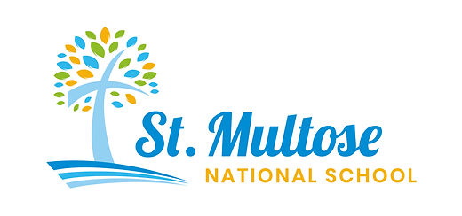 Newsletter 21st November 2025
Dear Parents,
Please find important information attached about our Hot School Meals which will begin on 12th January 2026. You’ll soon receive a welcome email directly from 360 BiaÓg with your child’s details and the next steps. All instructions on menus, allergens, and how to update your child’s choices will come directly from 360 Bia Óg in their welcome email. If you have questions about meals or menu changes, they will guide you once their email arrives.

Primary School Survey
Please do the following survey if you haven’t already done so. It will take about one minute! It gives you a voice as parents, about your preferences about the provision of different types of schools in Ireland.
https://www.gov.ie/en/department-of-education/campaigns/primary-school-survey/
School attendance
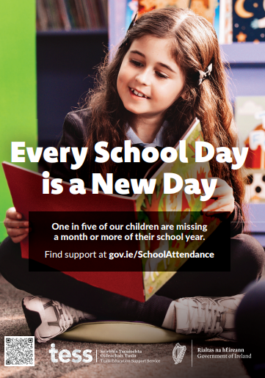
One in five children in Ireland are missing a month or more of their school year. This needs to change. Children benefit from being in school every day, unless they are sick. Please support your child’s education by ensuring they have good attendance.
A new support page has been developed in collaboration with key stakeholders and is available for parents and schools at www.gov.ie/schoolattendance with helpful guidance on many issues affecting school attendance.


Parents’ Association
The Parents’ Association AGM will be held in the school on Wednesday 3rd December at 7pm and we would love as many families to be represented as possible. You are very welcome!
TEAM HOPE CHRISTMAS SHOEBOX APPEAL
Thank you!
Twenty-two children from various countries are going to be delighted when they receive the beautiful Christmas Shoeboxes prepared by children in St. Multose. Many thanks to all the families who made a box this year.

Book Fair
We raised €833.50 from our Scholastic Book Fair. As a result, we have earned €416.75 in rewards for the school. Thank you to everyone for supporting this initiative. It is such a wonderful help in keeping our school library up-t- date with novels that the children will want to read.
Cork Pops Orchestra
We had a wonderful day at City Hall enjoying Evelyn Grant and the orchestra; playing everything from Star Wars and Jurassic Park theme tunes to Handel and Bach! We even sang along to the very popular song by Kingfishr, Killeigh, and enjoyed an up-and-coming singer, Keith Hanley with his rendition of K-Pop Demon Hunter, supported by the orchestra. The children were so well behaved and are a credit to their parents. St Multose were mentioned and were applauded from the stage for coming by public bus, something they want other schools to try, in the future! The major of Cork even came to chat with us as he was delighted in our ‘Green’ initiative.
Robotics
The senior room are once again getting involved with the VEX Robotics programme. Transition Year Students facilitated by the TY Co-ordinator in KCS, Niamh Hay, came to show the children what it’s all about. It really is a fabulous introduction to coding, building robots, motors, engineering, strategy development, collaborative process and much more. We really do appreciate receiving this support from KCS.
Kinsale Museum – Junior Room
On 27th November, the junior classroom are going to the Kinsale Museum to look at all the artefacts there from rural and home life. This is a wonderful opportunity for them to engage with history. Ms Curtin is also bringing them for hot chocolate. Lucky ducks!
Christmas Carol Singing at the Day Care Centre
On Wednesday 17th December, 2nd-6th class will go down to the Day Care Centre to sing Christmas Carols to all the older folk there. Thank you to Ms Roberts for arrangling this and to Mr Breen for accompanying us.
Drama Club
Drama Club is proving very popular. Parents involved with this will hear more in due course about upcoming performances.
Donation wanted, please!
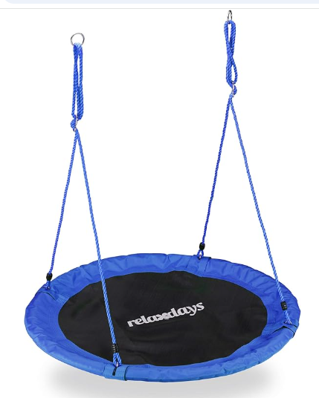
We are looking for a replacement for our basket swing. It has been enjoyed so much but has become a little worse for wear. Perhaps someone has one at home they are no longer using or perhaps someone would like to buy the school an early Christmas present?

Costumes
Mermaids vs Pirates: Your child should know what they are supposed to be wearing for their costume. Please send me an email if you are unsure. Please assist them in getting everything together. Please put it in a named plastic bag and send into school as soon as it is ready, ideally before the 10th of December.
Carol Service outfits (no uniform)
Junior room: Bobble hats, woolly scarves, Christmas jumpers
Middle room: Nativity costumes – details to follow from Ms Hadden
Senior room: Novelty headgear, black, red, white party clothes, the more glitter the better!
Upcoming dates for your diaries:
7pm, Monday 15th December: School Carol Service in St Multose Church
11.00am, Friday 19th December: A performance of the musical Pirates versus Mermaids, by the children in the senior room. All parents, pupils and staff will be warmly welcome!
12.30pm, Friday 19th December: End of term 12.00.

