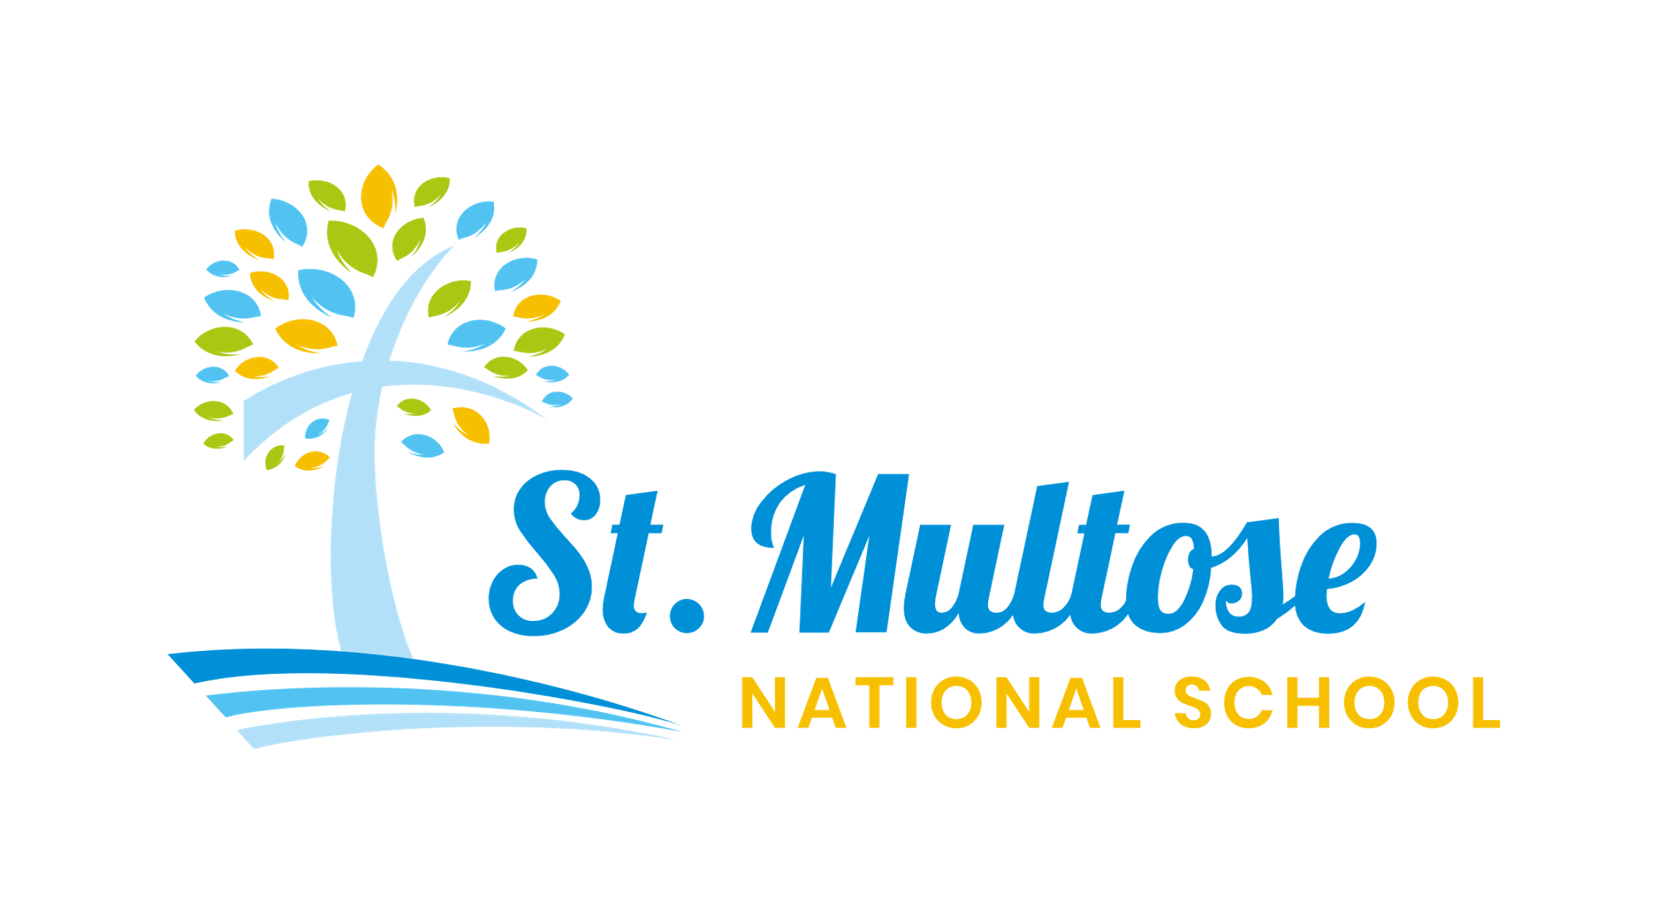
Acceptable Usage Policy

Policy ratified by Board of Management: September 2009
Reviewed: September 2014
Reviewed: January 2016
Reviewed: September 2018
Reviewed: September 2019
Reviewed: 13/10/2026

School Patron: The Right Rev. Andrew Orr,
Bishop of Cork, Cloyne and Ross
School Address: Knocknabohilly, Kinsale, Co Cork, P17 AF10
Registered Charity Number: 20112844
Tel: 021 477 4106
Email: principal@stmultosens.ie
Roll number: 14726C
www.stmultosens.ie

Chairperson: Reverend Eugene Griffin
Principal: Ms Jill Horan

Rationale:
An Acceptable Use Policy (AUP) is an important document that governs pupils’ use of the internet at school and covers a wide range of issues related to rights, responsibilities, and privileges – as well as sanctions – connected with computer use. (www.webwise.ie)

Aim:
Acceptable Use Policy (AUP) is to ensure that pupils will benefit from learning opportunities offered by the school’s internet resources safely and effectively. Internet use and access at school are considered a school resource and a privilege. Therefore, if the school AUP is not adhered to, this privilege will be withdrawn, and appropriate sanctions, as outlined in the AUP, will be imposed.
This version of the AUP was updated in following collaboration between Teachers, Parents, BOM and Óide, Technology in Education. The AUP will be reviewed every year by school and parent representatives. Before signing, the AUP should be read carefully to indicate that the conditions of use are accepted and understood.

Digital Technology and Internet Access in School
Digital Technology has brought profound changes to almost all aspects of our lives in recent years. It has transformed activities as basic as how we work, communicate with each other, treat illnesses, travel, shop and enjoy our leisure time. It has also had a huge impact on education and schools. Digital Technology and internet access have opened a whole new world of teaching and learning in schools. While they should never replace teacher/pupil contact, online and digital learning platforms can provide an extra dimension to how schools operate. This is particularly important during times when schools may need to close unexpectedly for indefinite periods of time.
The internet is an essential element for education, business and social interaction. Internet use is part of the curriculum and a necessary tool for education. Providing access to the Internet in school will raise educational standards and support the professional work of staff. Teachers and pupils will have access to websites worldwide, for example, museums, art galleries, etc., offering educational resources, news and current events. It provides opportunities for discussion with experts in many fields and to communicate and exchange information with pupils and others worldwide. In addition, staff have the opportunity to access educational materials and good curriculum practice, to communicate with the advisory and support services, professional associations and colleagues, and exchange curriculum and administration data with other schools and educational centres.
The internet may also be used to enhance the school’s management information and business administration systems. St Multose National School currently employs Aladdin as our current School Management Data System.
This Acceptable Use Policy will address all rights, privileges, responsibilities and sanctions associated with access to and use of the internet in St Multose National School.

School Strategies:
This policy has been drawn up to protect our pupils from the risks associated with the internet while they are at school or engaging in online distance learning. Parents and Guardians are advised, however, that while the children may be given internet-based homework assignments from time to time, the school take no responsibility for the internet usage of the pupils while they are outside school. All parents and guardians must monitor their own child’s internet usage at home and ensure that their children are aware and respectful of the risks involved.
Due to the international scale and linked nature of information available via the Internet, it is not possible to guarantee that particular types of material will never appear on a computer screen. Neither the school nor the Board of Management can accept liability for the material accessed, or any consequences thereof. The school employs several strategies to maximise learning opportunities and reduce risks associated with the Internet. These strategies are as follows:

General
• All staff and any other adults involved in supervising children accessing the Internet will be provided with this Acceptable Use Policy and will have its importance explained to them.
• Parents’ attention will be drawn to the Acceptable Use Policy on enrolment of their child in the school. The policy will be published on our school website.
• Internet access will always be supervised by a teacher.
• Broadband is installed by the Department of Education & Science, and a centrally managed service has been provided to our school. This includes filtering, website blocking, web content blocking, antivirus and anti-spam controls.
• Uploading and downloading of non-approved software will not be permitted. Virus protection will be used and updated on a regular basis.
• Pupils, parents and staff are advised to visit www.webwise.ie for information on the safe usage of the internet.
• The use of any form of removable storage or other digital storage media (such as memory sticks, etc.) requires a teacher’s permission. The senior classes own a memory key for educational use only, and this is used at the discretion of the teacher.
• Teachers using interactive whiteboards and projectors must be particularly vigilant and must preview the material being presented to ensure that it is age-appropriate and adheres to the conditions of this AUP.
• Pupils should never attempt to upload or download software, music or videos without the prior permission of a staff member.
• Pupils should never access games (or other) websites or apps without the prior permission of a teacher.
• Pupils will always observe good ‘netiquette’ (i.e. etiquette on the internet) and will not undertake any actions that may bring the school into disrepute. Good netiquette will be demonstrated to the children through activities on www.webwise.ie, MySelfie and other digital literacy resources.
• It is important that parents/ guardians and pupils are aware of our Bí Cineálta Policy in relation to cyberbullying.
• However, it should be noted that in the context of this policy, placing a one-off offensive or hurtful public message, image or statement on a social network site or other public forum where that message, image or statement can be viewed and/or repeated by other people will be regarded as bullying behaviour, whether it is sent during school hours or after. The parents will be informed that It is in the remit of An Garda Síochána to follow up on any reports of cyberbullying.
• Specific lessons on Internet Safety and Netiquette will be taught during the Media Education unit of SPHE.

World Wide Web
• All websites and apps accessed must be approved by the teacher.
• Neither pupils nor staff (including people employed by the school/contractors etc.) may visit Internet sites that contain obscene, illegal, hateful or otherwise objectionable materials. Any breach will be dealt with by the Board of Management's disciplinary procedures and/or child protection procedures. The school also reserves the right to report any illegal activities to the appropriate authorities.
• Pupils will not intentionally visit internet sites that contain obscene, illegal, hateful or otherwise objectionable materials.
• Pupils will report accidental accessing of inappropriate materials in accordance with school procedures.
• Pupils will use the internet for educational purposes only during class times.
• Pupils will be taught about copyright issues relating to online learning. Pupils who copy information or images from the Web into their assignments will acknowledge the source.
• Pupils will never disclose or publicise personal information.
• Downloading materials or images not relevant to their studies is in direct breach of the school’s Acceptable Usage Policy. Pupils will be aware that any usage, including distributing or receiving information, school-related or personal, may be monitored for unusual activity, security and/or network management reasons.
E-mail
No pupils will have access to email facilities at school. Any emails to other children/schools will be sent through the school email address by the teacher. An exception to this rule is through the Writing Genre Writing to Socialise. The school Chromebooks are email-enabled for this purpose.

Web 2.0
With the advent of Web 2.0, the internet has become a two-way communication system for the school and the wider community and an invaluable resource for distance learning. Services such as Aladdin, Seesaw, Facebook, Zoom, Instagram, Padlet, and other online tools/social media may be used by the school to communicate with parents and pupils, and for parents and pupils to communicate with the school. These services, although not owned by St Multose National School, form part of our web services and all content that is placed on these services falls under this policy. The safety of our children on the web is of utmost importance, so the following rules apply to the school and parents. Web 2.0 is open to potential dangers when used inappropriately.

We would ask:
Many social media sites have minimum age requirements. While the school will not monitor this, we would advise parents not to allow their children to have personal accounts on Facebook, WhatsApp, Snapchat, etc. until they are of the appropriate age.
• Parents and guardians are encouraged to regularly check their child’s online activity/digital footprint. Parents are encouraged to check social media apps (e.g. Facebook, Snapchat, Zoom, Viber, WhatsApp, Instagram and Picture Gallery, etc) on mobile phones and electronic devices to ensure they are aware of their child’s online interaction with others and approve of the same.
• Please do not “tag” photographs or engage in any other content which would identify any children or staff in the school.
• If you are uploading a photograph, please ensure that it does not identify the child in any way.
• Please ensure that online messages and comments to the school are respectful. Any messages written on social media are treated in the same way as written messages to the school.
• Avoid any negative conversations about children, staff or parents on social media accounts.
• Please do not request to “friend” a member of staff in the school. The staff would like to keep their personal lives personal. It may be awkward for a staff member to be asked to ignore a Facebook or other social network request.
• If parents/guardians use a Digital Device to record video or take photos at any time on school property, e.g. at a school concert, the onus is on that parent/guardian to ensure that the recordings/photos are only to be used for personal use. At no time should they be posted on any form of social media. At all times, we need to be respectful and vigilant of the privacy and wishes of other pupils and families.
• Failure to keep the above rules will result in a permanent ban from our Web 2.0 services and social media accounts.
• The AUP and its contents also apply to any pupils who have been granted Assistive Technology and use their assigned devices at school and at home. Class teachers will regularly check the browsing history of these devices to ensure that no inappropriate material is being searched, as the devices remain the property of the school.

School Website and Social Media, Including Digital Learning Platforms
• Pupils may be allowed to publish projects, artwork or schoolwork on the school website and/or social media accounts (Instagram account), including digital learning platforms. e.g. Seesaw
• The publication of student work will be co-ordinated and overseen by the class teacher.
• The website/platforms will be regularly checked to ensure that no content compromises the safety of pupils or staff
• Pupils’ work will appear in an educational context on web pages.
• Digital photographs or video clips of individual students will not be published on the school website. Instead, photographs and video clips will focus on group activities.
• Where a photograph, audio or video clip of a child is published, the child’s name will not be used
• Surnames will never be used on the website.
• Photographs and video clips should not show children wearing name badges.
• Personal pupil information, including home address and contact details, will never be published on the school website.
• Pupils will continue to own the copyright on any work published.
SCHOOL FACEBOOK AND INSTAGRAM ACCOUNTS (X ACCOUNT)

Mobile Phones/Electronic Devices
• Children in the Junior Classes should never have a mobile phone or other electronic device at school with them.
• In the Senior Classes, we acknowledge that sometimes parents would like children to have a mobile phone. While at school, this must be switched off and put in the child’s schoolbag. If a parent wants a child to have their phone in school, they must sign a permission slip.
• All communication between children and parents during the school day must be through the office or the class teacher.
• The school acknowledges the usefulness and practicality of electronic devices and recognises their potential as an educational resource.
• The unauthorised taking of images with a mobile phone camera or electronic device, still or moving, by a pupil in school, is in direct breach of the school’s Acceptable Usage Policy. For example, mobile phones, smartwatches or laptops/tablets.
• Pupils sending nuisance text messages is a direct breach of the school’s acceptable use. Refer to our Bí Cineálta Policy.
• As new technology keeps developing, please note that any device that can make calls, send messages or take pictures, such as, but not exclusively, Smart Watches, also fall under Electronic Devices and is not acceptable. They too should be switched off and kept in a bag to ensure no child can contact the outside world through text or call, unless through the secretary’s office.
• We do not accept placing the device in ‘School Mode’ as acceptable, as a) parents may forget to do so and b) children will figure out how to switch it back to ‘Non-school’ mode, and the teacher may not be aware. Having the device switched off and in their bag is the safest solution.
• If a device is seen or heard outside the child’s bag, they will be given a warning to turn it off and return to their bag. (We understand mistakes can be made.) If a second instance occurs, the device will be confiscated by the class teacher and returned to the child at the end of the day.
• If a third instance occurs, the device will be confiscated and sent to the principal’s office. An email will be sent to the parent indicating they will need to come in person to collect the device from the principal, where they will be directed to review this Acceptable Use Policy.
• In unusual circumstances, whereby pupils are still under the supervision of class teachers outside of school hours, such as at school sports matches, etc., from 2.30 pm onwards, the class teacher will contact any parent as needed. devices should not be used for any other purpose at this time, such as engaging in social media or taking photos, etc.
Sanctions
Misuse of the internet may result in disciplinary action, including written warnings, withdrawal of access privileges and, in extreme cases, suspension or expulsion. The school also reserves the right to report any illegal activities to the appropriate authorities. Please refer to our school Bí Cineálta and Code of Behaviour documents for further information.

Legislation
The following legislation relates to the use of the internet, which parents, students and teachers should familiarise themselves with:
• Child Trafficking & Pornography Act 1998
• Interception Act 1993
• Video Recordings Act 1989
• The Data Protection (Amendment) Act 2003
• The Data Protection Act 2018
• GDPR Guidelines 2018
• Bí Cineálta Guidelines (2024)
• Education (Smartphones in Primary Schools ) Bill 2024 Support Structures
• NCTE - http://www.ncte.ie/InternetSafety/
• Webwise - http://www.webwise.ie/
• Make IT Secure - http://makeitsecure.ie
• Safe Internet - http://www.saferinternet.org/ww/en/pub/insafe/
• Technical Support – www.techsure.ie
• Parental Advice and Tips - https://www.gov.ie/en/publication/673340parenting/

This policy was ratified by the Board of Management on ______________________

